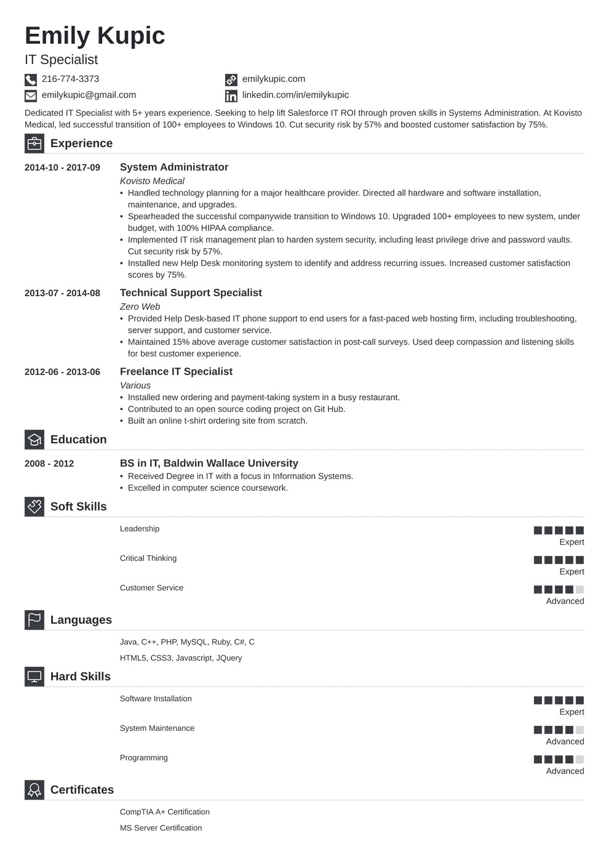
Emily Kupic
IT Specialist
216-774-3373
emilykupic@gmail.com
emilykupic.com linkedin.com/in/emilykupic
Dedicated IT Specialist with 5+ years experience. Seeking to help lift Salesforce IT ROI through proven skills in Systems Administration. At Kovisto Medical, led successful transition of 100+ employees to Windows 10. Cut security risk by 57% and boosted customer satisfaction by 75%.
Experience
2014-10-2017-09
2013-07-2014-08
2012-06-2013-06
Education
2008 - 2012
Soft Skills
System Administrator
Kovisto Medical
• Handled technology planning for a major healthcare provider. Directed all hardware and software installation, maintenance, and upgrades.
• Spearheaded the successful companywide transition to Windows 10. Upgraded 100+ employees to new system, under budget, with 100% HIPAA compliance.
• Implemented IT risk management plan to harden system security, including least privilege drive and password vaults. Cut security risk by 57%.
• Installed new Help Desk monitoring system to identify and address recurring issues. Increased customer satisfaction scores by 75%.
Technical Support Specialist
Zero Web
• Provided Help Desk-based IT phone support to end users for a fast-paced web hosting firm, including troubleshooting, server support, and customer service.
• Maintained 15% above average customer satisfaction in post-call surveys. Used deep compassion and listening skills for best customer experience.
Freelance IT Specialist
Various
• Installed new ordering and payment-taking system in a busy restaurant.
• Contributed to an open source coding project on Git Hub.
• Built an online t-shirt ordering site from scratch.
BS in IT, Baldwin Wallace University
• Received Degree in IT with a focus in Information Systems. • Excelled in computer science coursework.
Leadership
Critical Thinking
Expert
Languages
Hard Skills
Customer Service
Java, C++, PHP, MySQL, Ruby, C#, C HTML5, CSS3, Javascript, JQuery
Software Installation
System Maintenance
Certificates
Programming
CompTIA A+ Certification
MS Server Certification
Expert
Advanced
Expert
Advanced
Advanced

